**Project -2**

* Go to s3 console
* Create a s3 bucket (bucket name should be same as domain name)

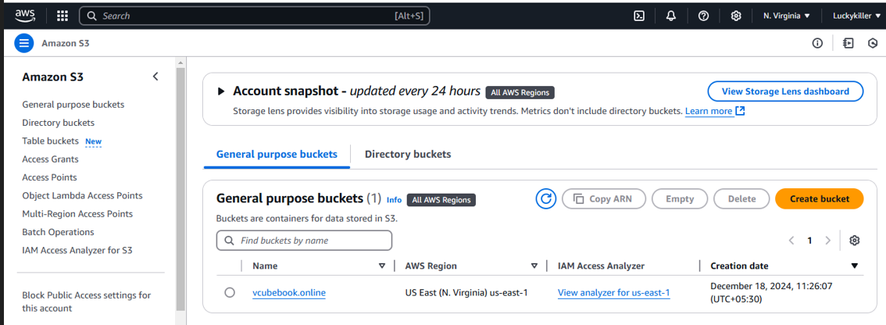

* Upload a file in bucket for static web hosting for that we need to upload .html file

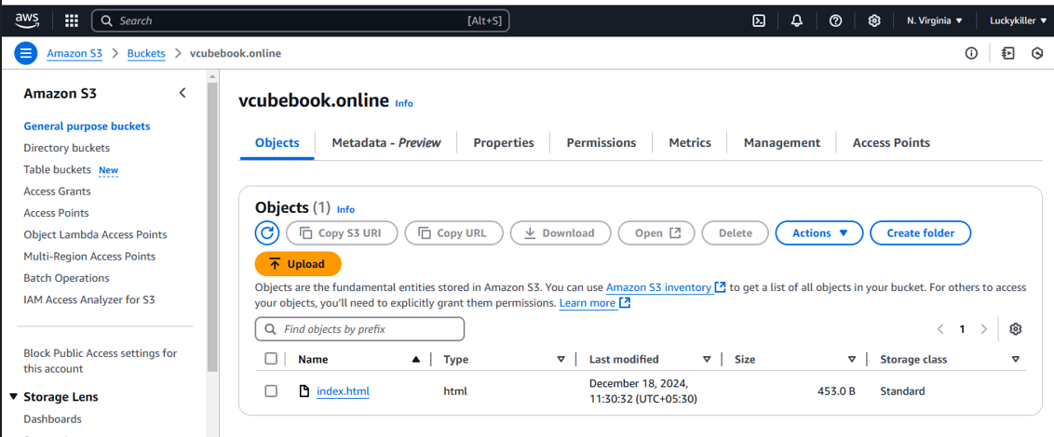

* Need to enable static web hosting for that open bucket and click on properties
* Now create json policy for that click on permission

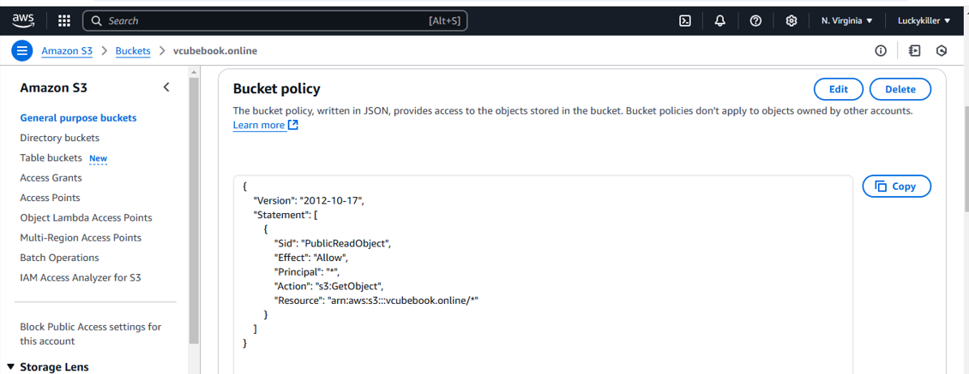

* Once we created a policy we will get static web hosting url

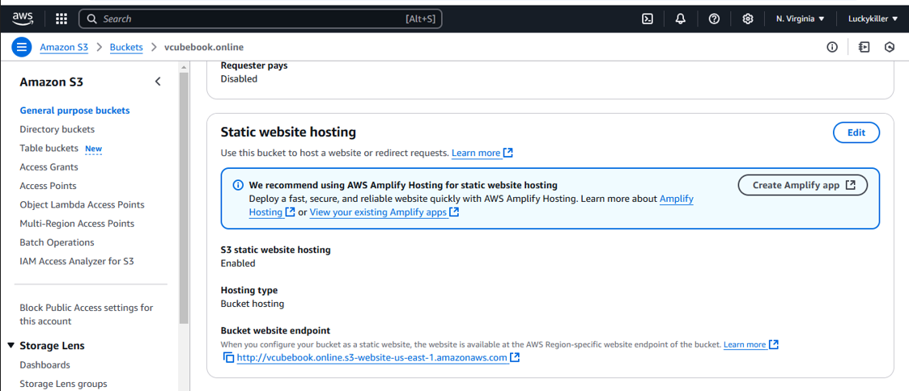

* Copy the url and paste it on web that we will get frontend page

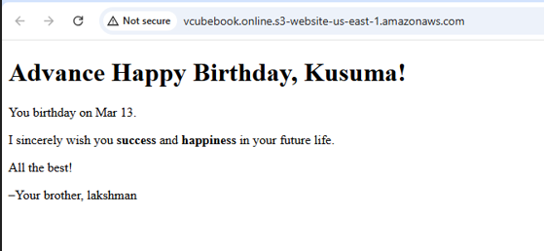

* Now goto Route 53 and create hosted zone

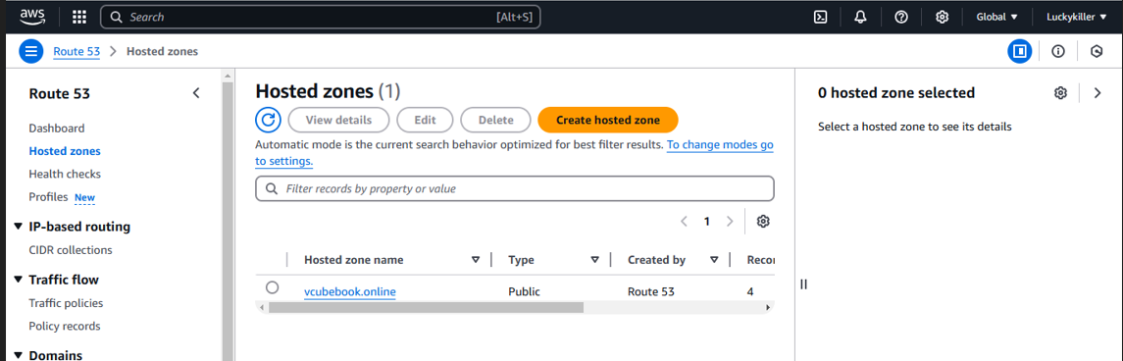

* Now creare a new record in hosted zone
* In record select s3 static web hosting

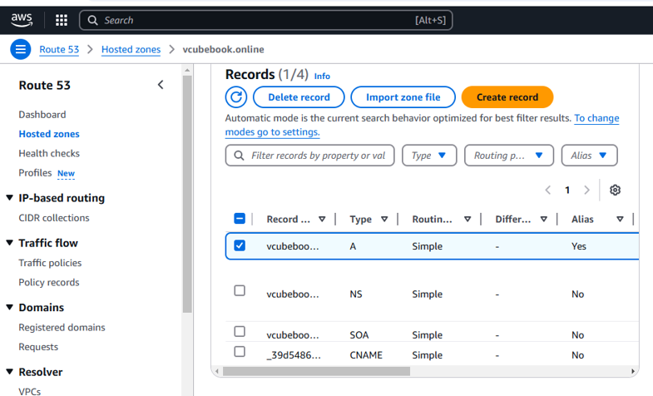

* We need to map our naming servers to domain name in hostinger

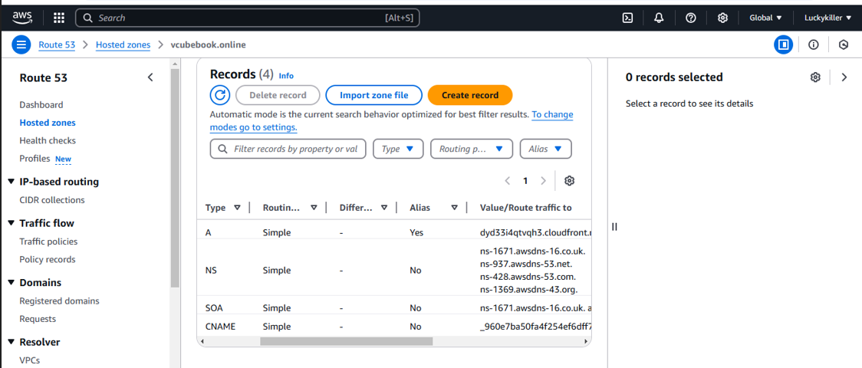

* Now can access our html file with domainname shows in below figure

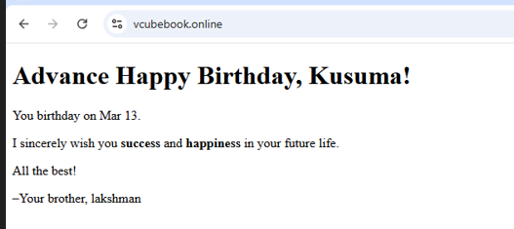

* Now we can access our frontpage through static web hosting and domain name
* But it is connecting like not secure



* Here our main aim is to connect as secure connection
* To connect secure we need to create certificate in ACM
* Go to ACM console and request certificate
* request went successful but it will remain in “pending validation” status until you valide it through DNS. For that click on “View certificate”

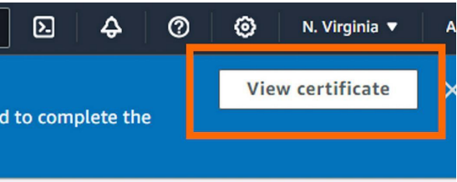

* Click on Create records in Route 53
* Select your domain and click on Create records
* You’ll notice a fresh CNAME record generated by Certificate Manager



* Now goto cloud front and create distribution
* Origin domain: If you click on the filter it should appears in Amazon S3 your website files.
* Click on “Use website endpoint” and AWS will update the endpoint for you.
* Scroll down until the section “Default cache behaviour”
* Viewer protocol policy: Redirect HTTP to HTTPS

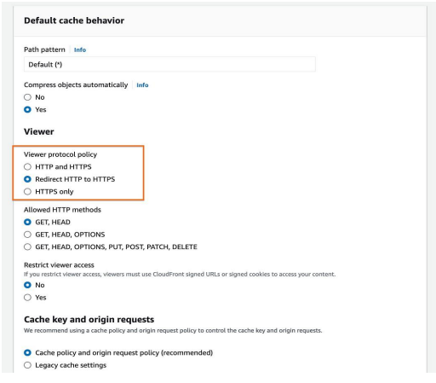

* Web Application Firewall (WAF) Select “Do not enable security protection
* Alternate domain name (CNAME): Add item and enter your domain name (in my case “anaquirosa.com”)
* Custom SSL certificate: Choose the created certificate.
* Remember, if you created it in a region other than us-east-1 (N. Virginia), it won’t appear in this list.
* Default root object: Type “index.html” (your default homepage) and• then click “Create distribution”.

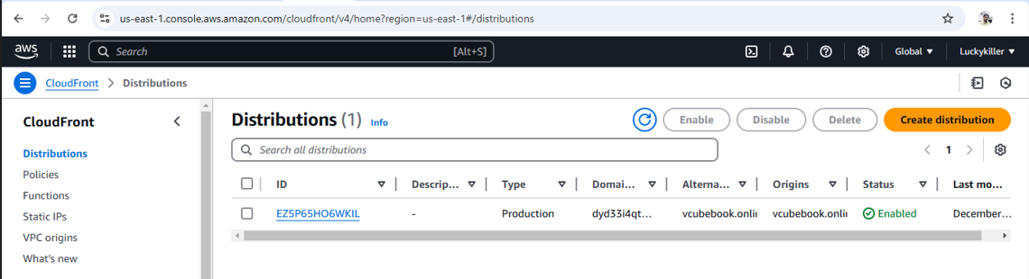

* Once distribution is created copy the distribution domain name which is showing in below figure

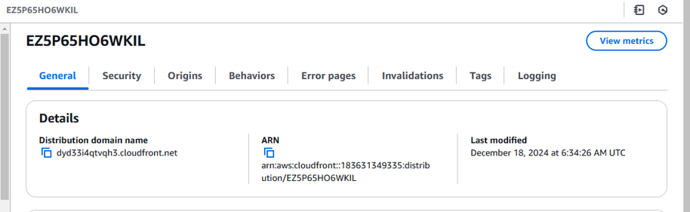

* Now copy the distribution domain name and paste it on web
* Now we can connect as secure connection

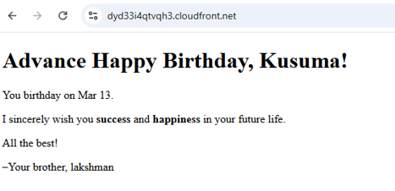

* Right now, Route 53 sends traffic to the S3 bucket.
* We want it to send traffic to the CloudFront distribution
* Goto route 53 and click on hosted zones
* Select the A record and then click Edit record

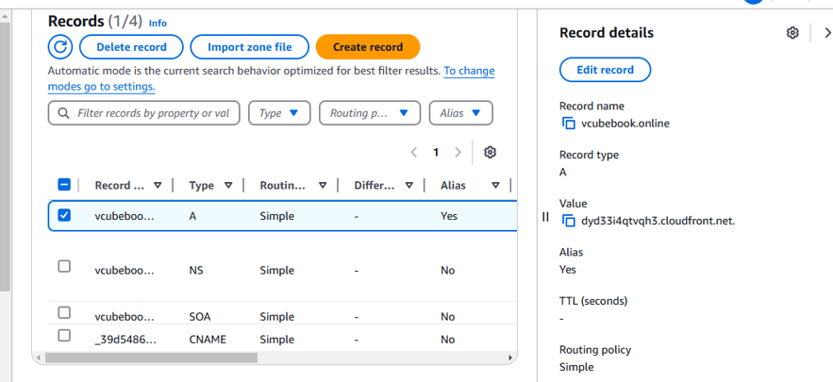

* Route traffic to: Alias to Cloudfront distribution.
* Choose Region: This option is selected for you and grayed out.
* Choose your distribution (it should automatically populate in thethird dropdown)
* Click Save
* Now can access our html file with domain name with secure connection shows in below figure

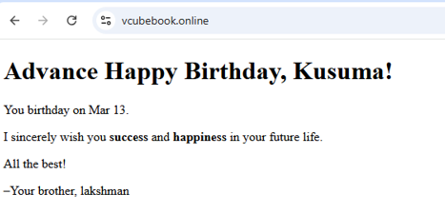

Final conclusion :

* Created a s3bucket and uploaded the .index file for static web hosting
* Created hosted zone with our domain name in route 53
* Onec we created we will get by default 2 records
* We need to create one more record to map our s3 web hosting to domain name
* Now we need to map our ns servers to domain name in hostinger
* Now we can access our html file with domain name
* Now we can access our frontpage through static web hosting and domain name
* Here our main aim is to connect as secure connection
* To connect secure we need to create certificate in ACM
* By using our certificate we need to create distribution in cloudfront
* Once distribution is created we can access secure connect with distribution domain name